Spectral coherence: EURUSD and USDJPY
Method 21 / daily log returns / Welch magnitude-squared coherence / Alpari D1 full available history

Study setup
Logical pair: EURUSD , USDJPY
Broker symbols: EURUSD_i , USDJPY_i
Snapshot: 2026-11-03_majors_alpari_D1
Timeframe: D1
Matched return window: 1999-01-05 to 2026-11-02 (UTC bar dates)
Matched return count n: 7200
Dropped unfinished last bar dated 2026-11-03 UTC after a tick-volume check against the prior complete day.
Welch: fs=1.0, nperseg=256, noverlap=128, window=hann, detrend=constant
Headline: gamma^2 nearest f=1/5; also 1/21 and 1/63
Complete matched rows (Excel): EURUSD-USDJPY_Spectral_D1.xlsx
Complete matched rows (HTML table): EURUSD-USDJPY_Spectral_D1_data.html

Method carried forward
Magnitude-squared spectral coherence gamma^2(f) measures shared linear power between matched daily log returns of close, ln(close_t / close_t-1), at each frequency f (cycles per day). Quotes are not inverted. Welch settings are frozen: fs=1, nperseg=256, noverlap=128, window=hann, detrend=constant. Headline is gamma^2 at the frequency bin nearest f=1/5 (five-day cycle from the formula sheet). Also reported: gamma^2 nearest f=1/21 and f=1/63, mean gamma^2 over the frequency grid, and phase of the cross-spectrum at the 1/5 bin. Coherence is unsigned (0 to 1); phase carries timing. Same-sample Pearson r is a side check only. This is not causation and not a trading signal.

Results (headline)
gamma^2 near 1/5: 0.138813
bin f (1/5): 0.199219
phase at 1/5 (rad): 2.699202
gamma^2 near 1/21: 0.156942
gamma^2 near 1/63: 0.053608
mean gamma^2: 0.115687
Pearson r: -0.300952

Target-frequency summary
period | target_f | f_bin | gamma2 | phase_rad
5 | 0.2 | 0.19921875 | 0.13881266 | 2.6992022
21 | 0.04761905 | 0.046875 | 0.15694214 | -2.6973364
63 | 0.01587302 | 0.015625 | 0.05360781 | 3.102882

Conclusion
Headline gamma^2 near f=1/5 for EURUSD and USDJPY: 0.1388 (bin f=0.199219, phase=2.6992 rad). At ~1/21: 0.1569; at ~1/63: 0.0536. Mean gamma^2 = 0.1157. Pearson r = -0.3010. This is frequency-domain linkage, not a trading signal.

Charts
Daily closes

Daily log returns

Spectral coherence gamma^2(f)
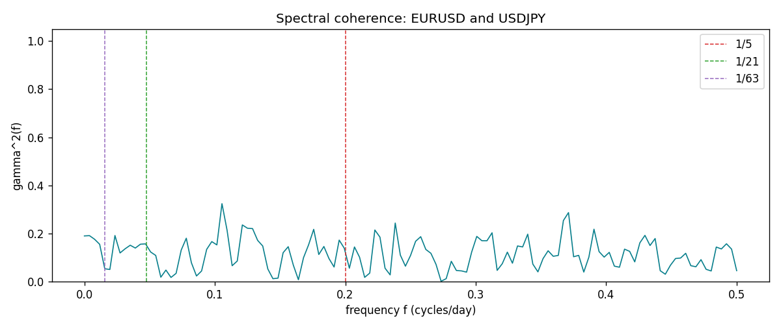

Data report
Matched rows and the coherence sheet are in the sibling Excel workbook named EURUSD-USDJPY_Spectral_D1.xlsx. Embedding all rows as a Word table is impractical; this file holds column summaries and the first and last 15 matched rows.
Columns: time, EURUSD_open, USDJPY_open, EURUSD_high, USDJPY_high, EURUSD_low, USDJPY_low, EURUSD_close, USDJPY_close, EURUSD_tick_volume, USDJPY_tick_volume, EURUSD_spread, USDJPY_spread, EURUSD_real_volume, USDJPY_real_volume, EURUSD_log_return, USDJPY_log_return
Column summaries (matched calculation rows)
column | count | mean | std | min | 25% | 50% | 75% | max
EURUSD_open | 7200 | 1.1812699 | 0.15089907 | 0.8272 | 1.086045 | 1.16609 | 1.2939325 | 1.5995
USDJPY_open | 7200 | 113.80877 | 19.206548 | 75.693 | 104.4225 | 110.983 | 120.69125 | 163.824
EURUSD_high | 7200 | 1.1864006 | 0.15149686 | 0.8326 | 1.0901575 | 1.17121 | 1.2991625 | 1.6038
USDJPY_high | 7200 | 114.3063 | 19.268128 | 76.001 | 104.878 | 111.441 | 121.26 | 163.978
EURUSD_low | 7200 | 1.1762568 | 0.15022122 | 0.8227 | 1.0819775 | 1.162475 | 1.288265 | 1.5865
USDJPY_low | 7200 | 113.28572 | 19.134551 | 75.402 | 103.8875 | 110.53 | 120.17 | 163.628
EURUSD_close | 7200 | 1.1813075 | 0.15087411 | 0.8267 | 1.085995 | 1.16602 | 1.2939425 | 1.5997
USDJPY_close | 7200 | 113.82186 | 19.221964 | 75.811 | 104.4165 | 111.023 | 120.6855 | 163.851
EURUSD_tick_volume | 7200 | 103020.56 | 173417.03 | 218 | 9398.5 | 52714 | 99443.25 | 1471626
USDJPY_tick_volume | 7200 | 106139.77 | 179306.98 | 149 | 9927.5 | 53095 | 92761 | 1803508
EURUSD_spread | 7200 | 19.389444 | 16.57873 | 0 | 8 | 12 | 30 | 50
USDJPY_spread | 7200 | 20.3175 | 17.636173 | 0 | 6 | 11 | 30 | 50
EURUSD_real_volume | 7200 | 4.0252061e+10 | 1.6676396e+11 | 0 | 0 | 0 | 0 | 3.6149665e+12
USDJPY_real_volume | 7200 | 3.4708591e+10 | 1.6077621e+11 | 0 | 0 | 0 | 0 | 3.8834203e+12
EURUSD_log_return | 7200 | -1.012e-05 | 0.00580063 | -0.03123819 | -0.0032472 | 0 | 0.00325137 | 0.03433183
USDJPY_log_return | 7200 | 4.989e-05 | 0.00620383 | -0.03908203 | -0.00319719 | 0.00011638 | 0.00340925 | 0.05184024
First 15 matched rows (selected columns)
time | EURUSD_log_return | USDJPY_log_return
1999-01-05 | -0.0048360507 | -0.00017868311
1999-01-06 | -0.011547966 | 0.0075660159
1999-01-07 | 0.0076280636 | -0.012851583
1999-01-08 | -0.010902799 | -0.0047719894
1999-01-11 | -0.007103287 | -0.016195423
1999-01-12 | 0.0045103728 | 0.032310364
1999-01-13 | 0.010845346 | 0.0081373171
1999-01-14 | 0 | 0
1999-01-15 | -0.010153245 | 0.0055343401
1999-01-18 | 0.0036256946 | 8.7600193e-05
1999-01-19 | -0.00017235436 | -0.0056219403
1999-01-20 | -0.0031939256 | -0.0053879917
1999-01-21 | 0.0030215416 | 0.0084664056
1999-01-22 | -0.0012075213 | 0.0060412564
1999-01-25 | -0.0030251979 | -0.0073594164
Last 15 matched rows (selected columns)
time | EURUSD_log_return | USDJPY_log_return
2026-10-13 | 0.0037402957 | -0.0018932826
2026-10-14 | -0.0037582255 | 7.5800166e-05
2026-10-15 | 0.0056053107 | -0.0018524319
2026-10-16 | 0.0017724895 | -0.00037976126
2026-10-19 | -0.0025394633 | 0.0034946841
2026-10-20 | 0.0023881672 | -0.0022546642
2026-10-21 | -0.00032046717 | -0.00032883504
2026-10-22 | -0.0015949606 | -0.0085942669
2026-10-23 | -0.001338521 | 0.00035080446
2026-10-26 | -0.0022706559 | 0.0041238746
2026-10-27 | -0.004152342 | 0.0027651658
2026-10-28 | 0.0022262927 | -0.00095679538
2026-10-29 | 0.0022571351 | -0.00038043789
2026-10-30 | -0.0011458446 | -0.0010596481
2026-11-02 | 0.002120569 | 0.0026438521
First 15 frequency bins
f | gamma2 | phase_rad | period_days
0 | 0.18998169 | 3.1415927 | inf
0.00390625 | 0.19119139 | -2.601612 | 256
0.0078125 | 0.1761863 | -2.9458639 | 128
0.01171875 | 0.15525673 | 3.0279774 | 85.333333
0.015625 | 0.05360781 | 3.102882 | 64
0.01953125 | 0.05046631 | 3.0414249 | 51.2
0.0234375 | 0.19173899 | 3.1071763 | 42.666667
0.02734375 | 0.11918921 | -2.9319962 | 36.571429
0.03125 | 0.13662221 | -3.1249509 | 32
0.03515625 | 0.15129445 | -3.0907269 | 28.444444
0.0390625 | 0.13959926 | -2.8816795 | 25.6
0.04296875 | 0.15559507 | -2.7259788 | 23.272727
0.046875 | 0.15694214 | -2.6973364 | 21.333333
0.05078125 | 0.12323306 | 2.9529035 | 19.692308
0.0546875 | 0.1088837 | 3.0415264 | 18.285714

